**DIESEL GENERATOR ENGINE**

**CUSTOMER : HYUNDAI MIPO DOCKYARD CO.LTD.ULSAN KOREA**

**REFERENCE No : APP – 1401058-00-REV-7**

**PROJECT NAME : HMD/H2528**

**DATE : 14.JAN.2014**

ENGINE TYPE : H21/32

SYNCHRONOUS GENERATOR : 1250 KVA , 08P , 450V , 60Hz . 3 SETS

**CAPACITOR DATA**

Maker: ELECTRONICON Made in Germany 33/14

Type: E62 C 58-502E10

MKP: 5 μF +/-10%

UN= 1000VDC, 640VAC

Temp: -25⁰C/+85⁰C

IEC 61071

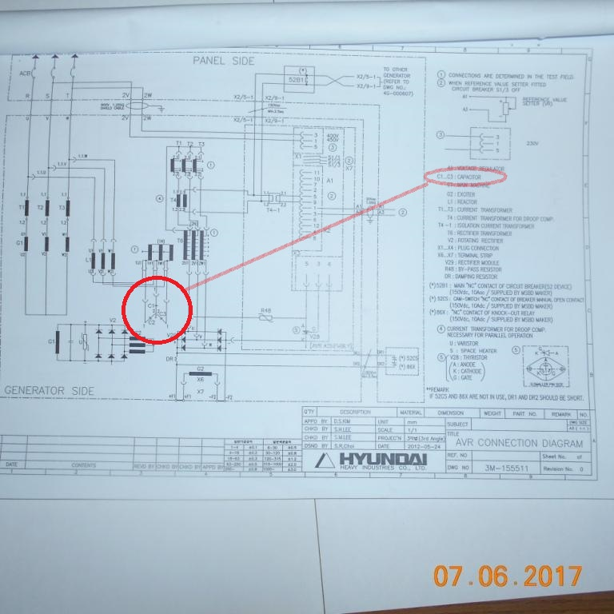

1. Drawing from Diesel Generator Manual (1/2)

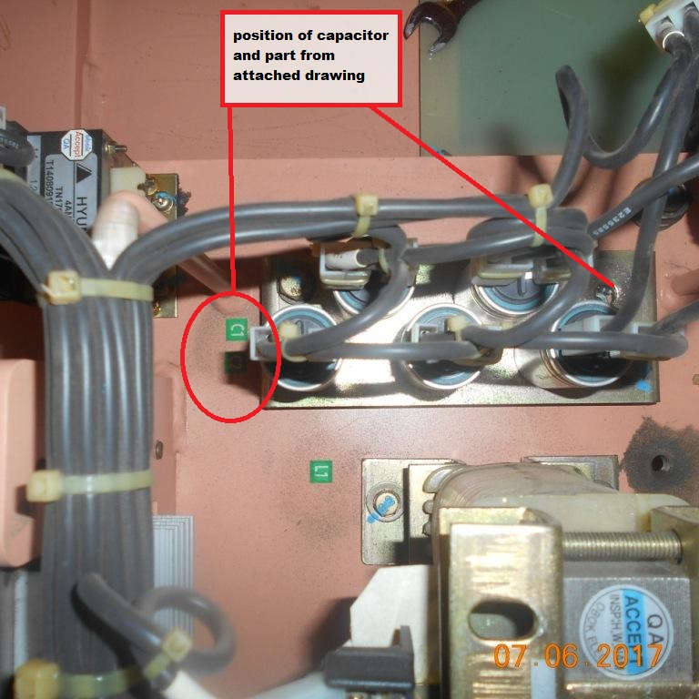

2. Position of Capacitor inside of Alternator Housing