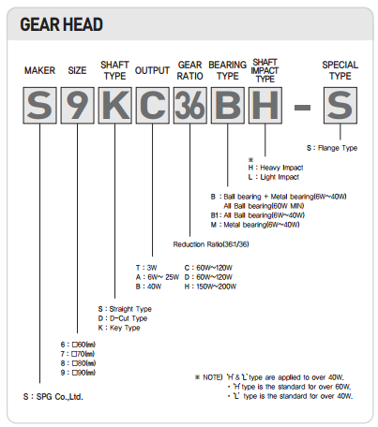

S 7 K A 15 B L

|  |  |  |  |  |  |
| --- | --- | --- | --- | --- | --- |
| Size | Shaft Type | Output | Gear Ratio | Bearing Type | Shaft Impact |
| 70mm | Key Type | 6~25W | 1/25 | Ball Bearing + Metal Bearing | Light Impact |